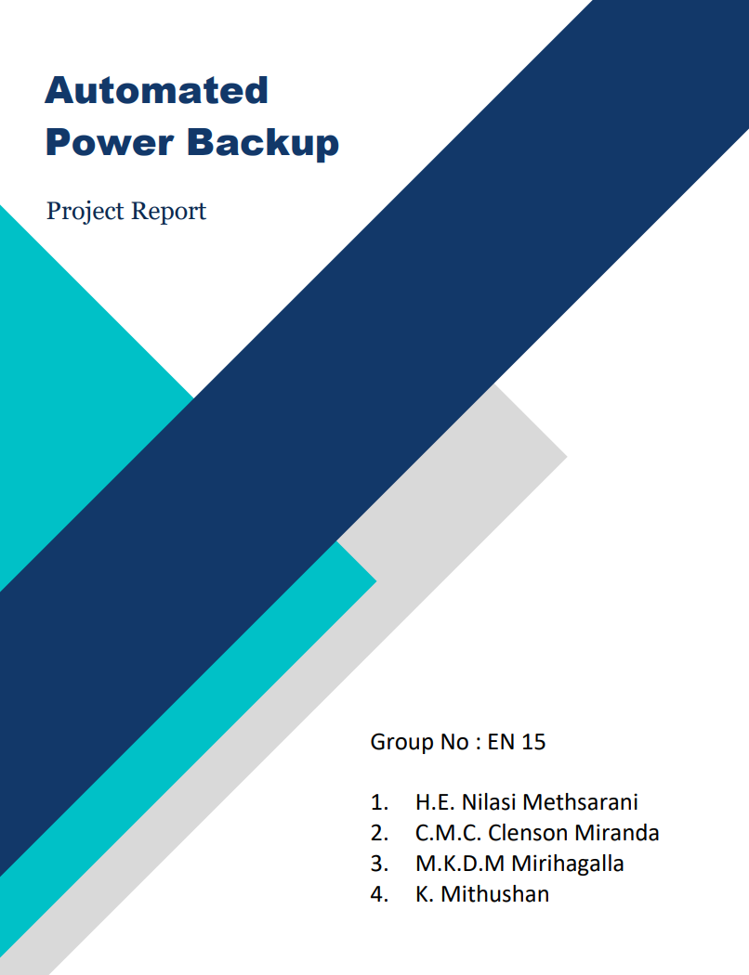
Abstract
The automated power backup provides an uninterrupted power to the Wi-Fi routers, so that users can experience a continuous internet connection even during the prevailing government-imposed blackouts along with the additional features of portable power bank and emergency lamp and users can be aware about the power remaining in the backup through the battery level indicator too.

Problem Description
The greatest power disruptions in over 25 years have been caused by government-imposed blackouts that have been in effect since January. Due to the current economic crisis in our nation, businesses and students were forced to maintain their work-from-home policies in order to cut down on travel expenses and ensure job continuity. Thus, the Wi-Fi networks in our homes are more reliant than ever.
Anyone with a Wi-Fi connection is aware that during power outages, their Wi-Fi will shut down. When a power outage occurs when we are participating in an online meeting, webinar, or lecture, it frustrates us. As a result, a sizable and varied set of wi-fi users want a solution to carry out their routine tasks without being interrupted. Use of automated power backup is among the best and simplest options for that.

Product Idea Validation
We conducted a survey among nearly 300 students with the aim of whether our idea is valid among the consumers. And the results were positive for us. So that we started to design our model. And below is the summary of our survey.
Nearly everyone in our nation has experienced a power outage. The majority of individuals currently experience one-to-three-hour power outages. The vast majority of people connect to the Internet via Wi-Fi technology. Many people are having trouble connecting to the Internet as a result of the continued power outages. The majority of them believe that constant internet connectivity and power outages can be solved by a power backup system. People anticipate a Wi-Fi power backup for 3 to 5 hours every day, according to poll data. Many users have stated that they like the USB connector, battery level indicator, and emergency lamp as extra features.

Enclosure Design

Initial Sketches (Hand-drawn)

Fig 3: Front View of enclosure (Hand-sketched)
Fig 2: Side View of enclosure (Hand-sketched)
Fig 1: Isometric View of enclosure (Hand-sketched)
Fig 4: Back View of enclosure (Hand-Sketched)



Initial Sketches (Solidworks)

Fig 6: Front View of enclosure (Solidworks)
Fig 5: Isometric View of enclosure (Solidworks)
Fig 7: Back View of enclosure (Solidworks)
Fig 8: Top View of enclosure (Solidworks)

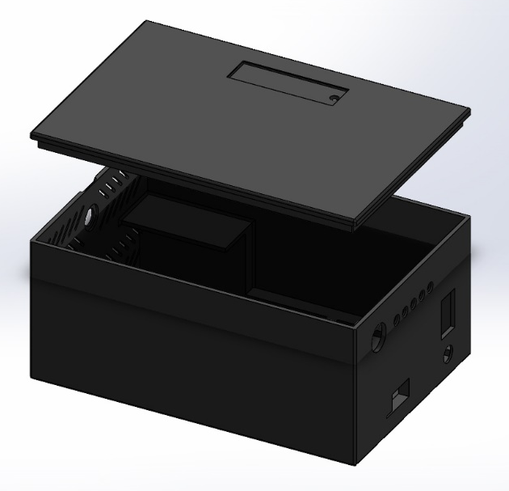
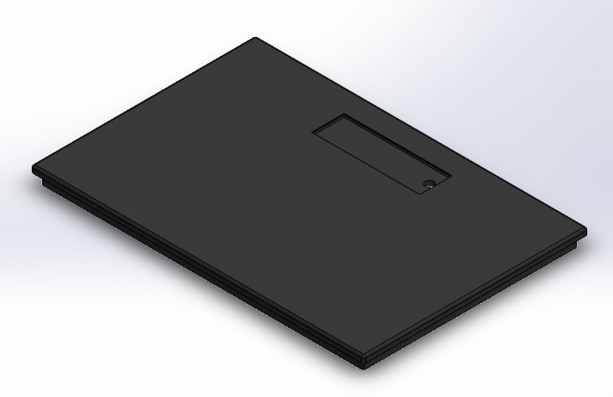
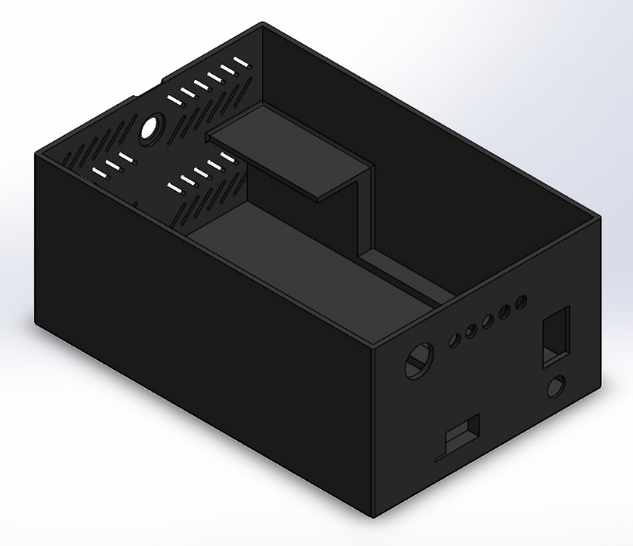
Final Sketches (Solidworks)
Fig 10: Isometric View of enclosure - base
Fig 9: Isometric View of enclosure - assembly

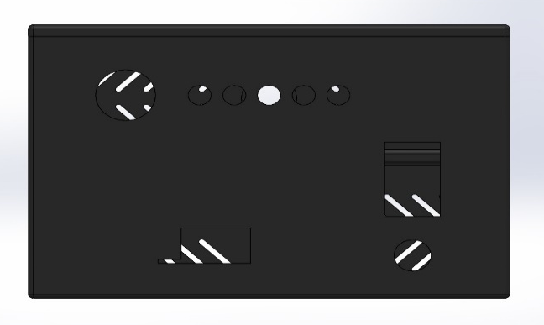
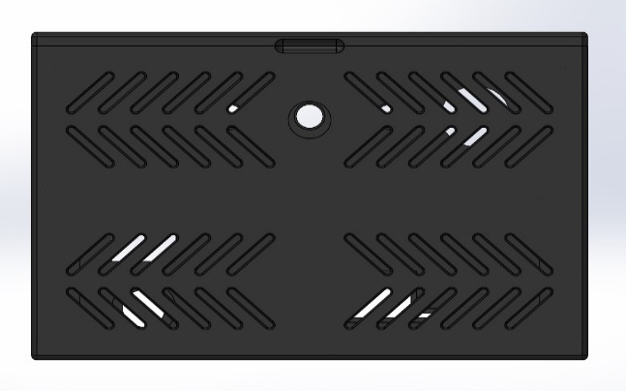
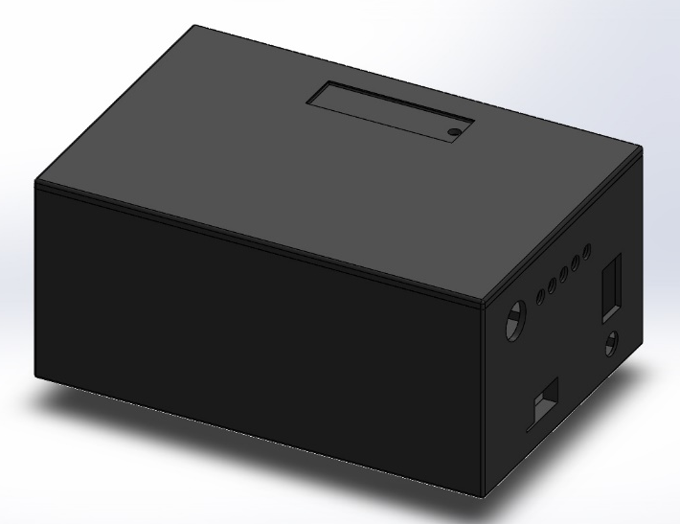
Fig 14: Isometric View of enclosure - Assembly
Fig 13: Front View of enclosure - base
Fig 11: Back View of enclosure - base
Fig 12: Isometric View of enclosure - lid

Product Architecture

Our design mainly contains the following blocks. This has aimed at mainly 3 things. Automated switching between the main power supply and backup power supply, regulating voltages to get the outputs 5V & 12V, and stepping up the voltages to get the required voltages to feed into the particular stages.
Fig 15: Block Diagram

Block 1: Booster Module
- MT3608 DC-DC Step Up Boost Power Supply Module is used to get a properly stable output.
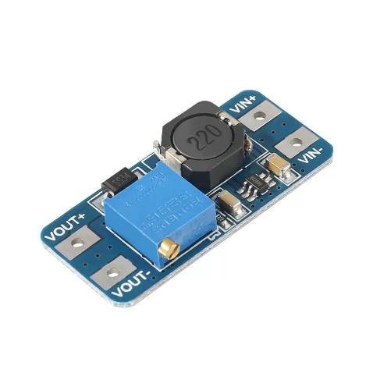
- Here we are expecting to set the output to 15V for the requirements of the other blocks.
Fig 17: Abstracted View of Regulator module
Fig 16: MT3608 Module
Block 2: Voltage Regulator
- Any input given to this block will result in either a 5V or 12V output, depending on the input.
- The routers will then be powered by the 12V output, while the USB port and the LED strip each receive 5V.
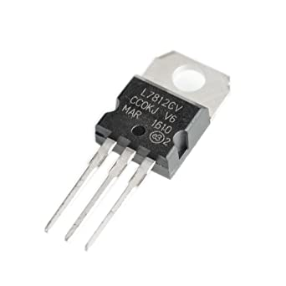
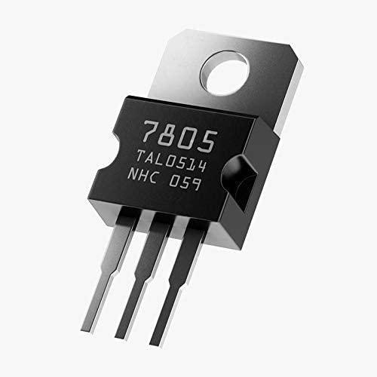
- We will employ regulated ICs to ensure the precise 12V and 5V. (7805 and 7812)
Fig 19: 7812 regulator IC
Fig 18: 7805 regulator IC
Fig 21: Circuit Diagram of Voltage Regulation
Fig 20: Voltage Regulator Model

Block 3: Switching Mechanism
- When power is available
➢ The transistor is at its saturation state.
➢ Then the relay is ON.
➢ Then the output voltage is given by the main supply (15V).

Fig 22: Switching Mechanism (When power is available)

- When power is not available
➢ The transistor is at the cutoff region.
➢ Relay is at its Normal close state(N/C)
➢ Rechargeable batteries will give the output voltage (14.8V).
Fig 23: Switching Mechanism (When power is not available)

Schematics and PCB Layouts

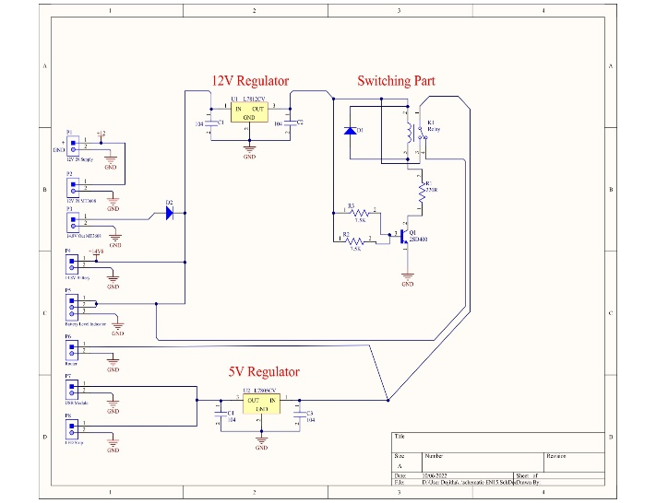
Altium Designer (22.7.1) was used to design schematic diagrams and PCBs. When designing PCB layouts 1 mm width is used for traces and 0.9 mm diameter is used for holes.
Fig 24: Schematic Diagram (Altium 2022)

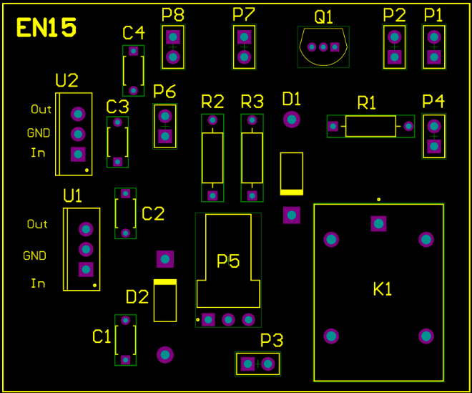

Fig 25: PCB Diagram -1 (Altium 2022)

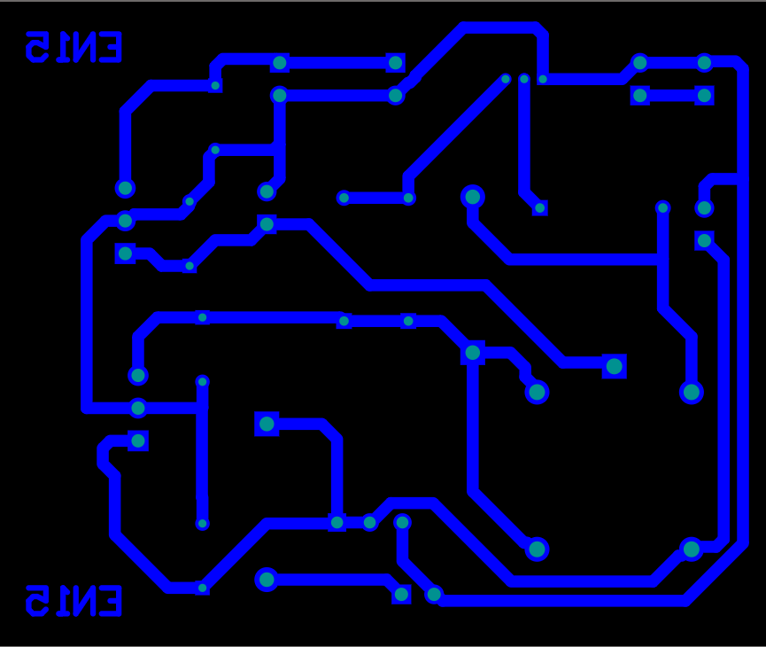

Fig 26: PCB Diagram -2 (Altium 2022)

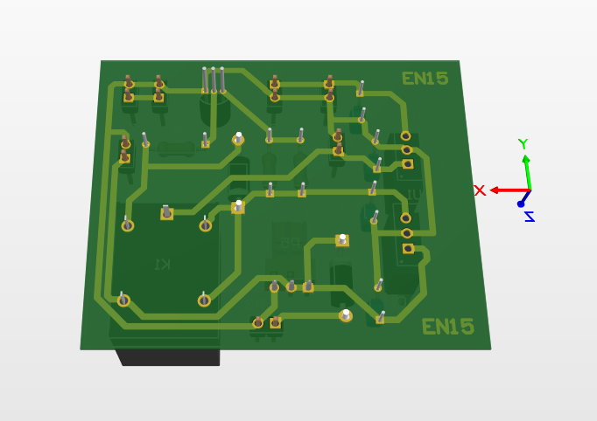

Fig 27: 3D View - Bottom (Altium 2022)

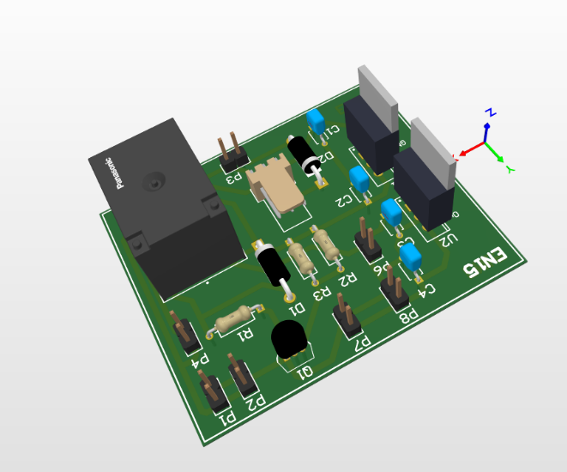

Fig 28: 3D View - Isometric (Altium 2022)

Technical Feasibility

- 12V DC power input for our product
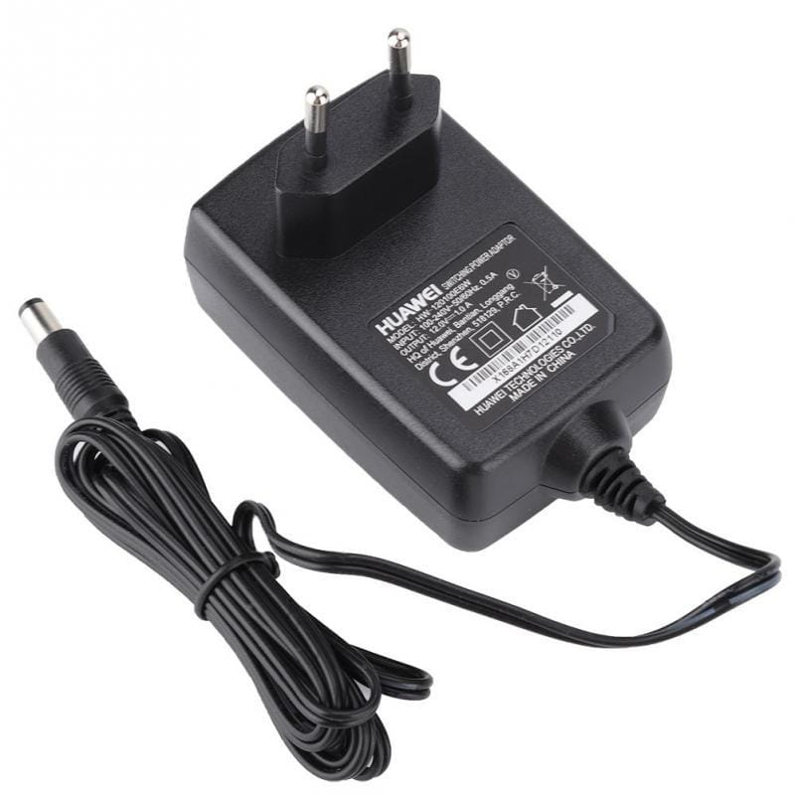
  - Users who own Wi-Fi routers also carry a 12V converter that changes a 220V AC supply to a 12V DC source. The 12V DC input for our product will be our first requirement. And we can do this by using the user's own adaptor.

Fig 29: 12V out DC adapter

- Automatic switching between grid power supply and backup power supply
  - When the main power supply is interrupted, our product uses lithium-ion (18650) batteries as a backup power source to keep the router running.
  - When there is electricity available from the main supply, we have planned to provide it. That may be used directly to power the router and charge the batteries simultaneously.
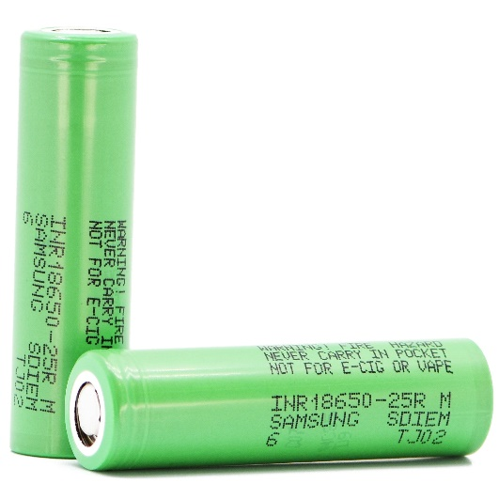
  - When there are power outages, the router will automatically draw power from batteries as a backup power source.

Fig 30: 18650 Li-ion Batteries

- 12V DC to 15V DC conversion to charge the batteries
  - We must keep the router's input voltage at 12 V DC to ensure appropriate router operation. We've used four lithium-ion batteries, each 3.7V, as the power backup. So that, the router will get power even when there is power available from the main supply. This is an ineffective method that could also shorten the battery life.
  - To solve this problem, we chose to increase the adapter's power output from 12V to 15V DC. Then we incorporate a system to automatically switch between supply and charge the batteries when power is available.
  - To do this, a step-up module (MT3608) is used in place of traditional step-up transformers to provide a lightweight, portable, and effective solution.

Fig 31: MT3608 Module
- 12V regulation
  - However, a new issue with the block's input voltage feeding appeared. Because none of the outputs are at the necessary 12V after being switched. Therefore, we added a regulating circuit that should produce 12V independent of the input. For this, we chose to employ the Regulator ICs.
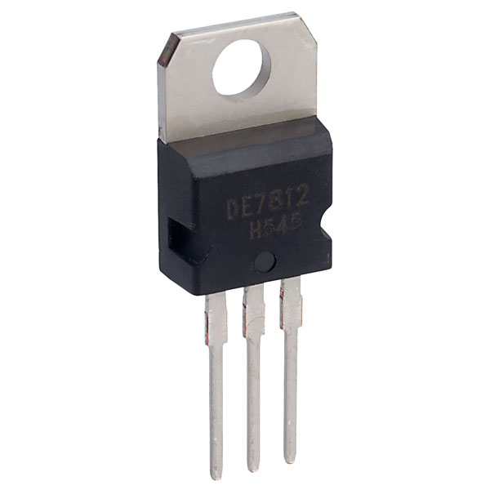

Fig 31: 7812 Regulator IC
- Battery level indication
  - We supplied five level indications. The number of LEDs that are on and glowing is directly related to the voltage of the batteries. However, batteries may deplete quickly if the indicators illuminate continually while they are in use.
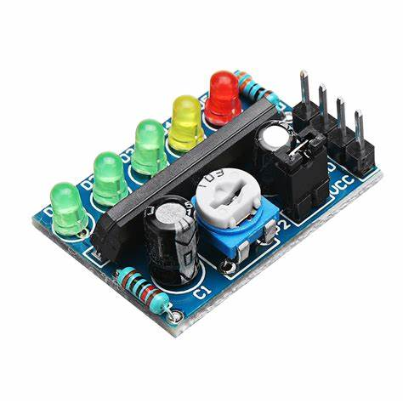
  - In order to solve this problem, we included a switch that links the system with the battery level indicator block. If we press the switch, the indicator will display the amount of battery life left; otherwise, it will remain off.

Fig 32: Batter Level Indicator Module (KA2284)

- Additional features
  - Additionally, we made the decision to add a few extra features to our product. In the design, a USB charging port and an LED strip were considered. Because power outages necessitate these amenities as well.
  - Therefore, we choose to change the earlier regulation block in order to provide two controlled DC voltages (12V and 5V). The router can be powered by 12V. For the LED strip and USB, 5V can be used.
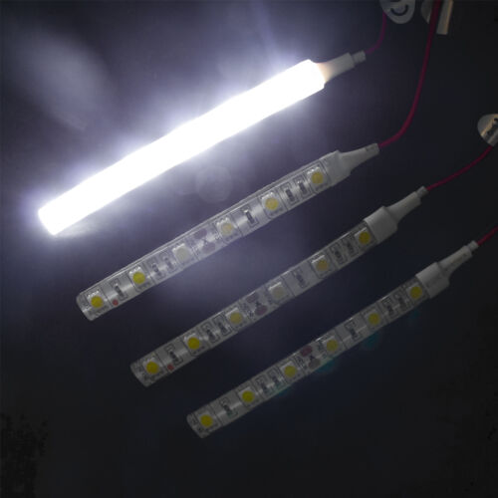
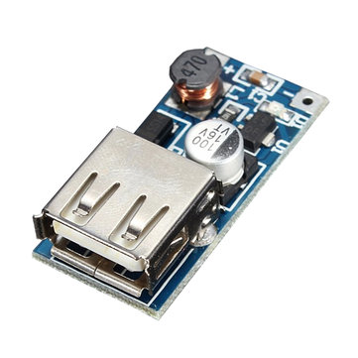

Fig 34: LED strip
Fig 33: USB module

Technical Specifications
- Accuracy of Measurements
  - A relay handles automatic switching, allowing the router's trip time to be ignored. Therefore, even in the event of a power outage, the router will continue to operate.
  - A module measures battery level. As a result, the indication's accuracy is also excellent.
  - The regulator ICs control the voltage at 12V and 5V (7812 and7805). This allows us to guarantee that the output voltage is precisely 12V and 5V.

- Power Consumption
  - Power usage may differ based on the router that a user connects in. Additionally, batteries will be quickly depleted if a user plugs in more USB-compatible devices. Here, it is advised that only a few appliances be connected to this device.

- Product Dimensions and weight
  - 100mm x 150mm x 60mm (w x l x h)
  - Weight = 500g

Project Budget
No. | Component | Price (LKR)
 | MT3608 | 300.00
 | 7805 IC | 30.00
 | 7812 IC | 50.00
 | 0.1 μF capacitors x 4 | 20.00
 | SPST relay (9V or 6V) | 100.00
 | D400 transistor | 40.00
 | Resistor 1k x 2 | 30.00
 | Battery level indicator | 400.00
 | 3.7 V Batteries x 4 | 2400.00
 | 5V LED strip | 300.00
 | USB module | 180.00
 | Wires and Switches | 150.00
 | Sub-total | 4000.00
 | PCB printing | 500.00
 | Enclosure Printing | 2500.00
 | Total | 7000.00

